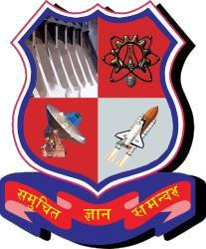 

**SARDAR VALLABHBHAI PATEL INSTITUTE OF TECHNOLOGY**

A REPORT ON

**HAND GESTURED ARDUINO ROBO**

Under the subject of

**DESIGN ENGINEERING-1B**

**B.E. II, Semester – IV**

**(COMPUTER ENGINEERING)**

Submitted by:

Group:

|  |  |  |
| --- | --- | --- |
| Sr. No. | Name of Student | Enrollment No. |
| 1 | Samruddhi Landge | 150410107037 |
| 2. | Krishna Mayavat | 150410107041 |
| 3. | Meet Soni | 150410107042 |
| 4. | Mitali Maniyar | 150410107048 |

Assistant Prof. Nisha Velani

(Faculty Guide)

Prof. Bijal Talati

(Head of the Department)

Academic year

(2016-2017)

**CONTENT**

1. **Introduction**…………………………………………………………………………..3
   1. About our project………………………………………………………………….3
2. **Reverse Engineering**……………………………………………………………….3
   1. Technical aspects and components…………………………………………3
   2. Product Description………………………………………………………………..5
   3. Preparation of canvases………………………………………………………….6
   4. Feedback Analysis……………………………………………………………….…..9
   5. Summary of findings....................................................................9
   6. Summary of learning from reverse analysis...............................9
3. **Pre-Design**……………………………………………………….........................10
   1. Learning Need Matrix(LNM)………………………………………….................…….10

**1. INTRODUCTION**

Our project is Hand Gestured Arduino Robo in which we are using an Arduino microcontroller. Our domain area is robotics and automation. Since today’s world is the world of technology, many people are mainly dependent on automated things. We have specifically selected to automate the regions such as mines in which human have to risk their lives in terrible and intense hot temperature.

Therefore this project is mainly made by the point to automate such areas in which there is risk to human lives such as coal or gold mines where temperatures are too high and no proper oxygen levels are there.

To implement this on a lower scale we would be using Accelerometer, RF transmitter and receiver technology. Also an arm gripper is used to lift some things. Other than this there are also many other components like using a camera and a torch or led etc.

**2. REVERSE ENGINEERING**

**2.1 Technical aspects and Components:**

1. **Arduino:**

Arduino is an open-source electronics platform based on easy-to-use hardware and software. Arduino boards are able to read inputs - light on a sensor, a finger on a button, or a Twitter message - and turn it into an output - activating a motor, turning on an LED, publishing something online.

You can tell your board what to do by sending a set of instructions to the microcontroller on the board. To do so you use the Arduino programming language (based on Wiring), and the Arduino Software (IDE), based on Processing.

Over the years Arduino has been the brain of thousands of projects, from everyday objects to complex scientific instruments. A worldwide community of makers - students, hobbyists, artists, programmers, and professionals - has gathered around this open-source platform, their contributions have added up to an incredible amount of accessible knowledge that can be of great help to novices and experts alike.

1. **Accelerometer Sensor:**

An accelerometer is an electromechanical device that will measure acceleration forces. These forces may be static, like the constant force of gravity pulling at your feet, or they could be dynamic - caused by moving or vibrating the accelerometer.

By measuring the amount of static acceleration due to gravity, you can find out the angle the device is tilted at with respect to the earth. By sensing the amount of dynamic acceleration, you can analyze the way the device is moving. At first, measuring tilt and acceleration doesn't seem all that exciting. However, engineers have come up with many ways to make really useful products with them.

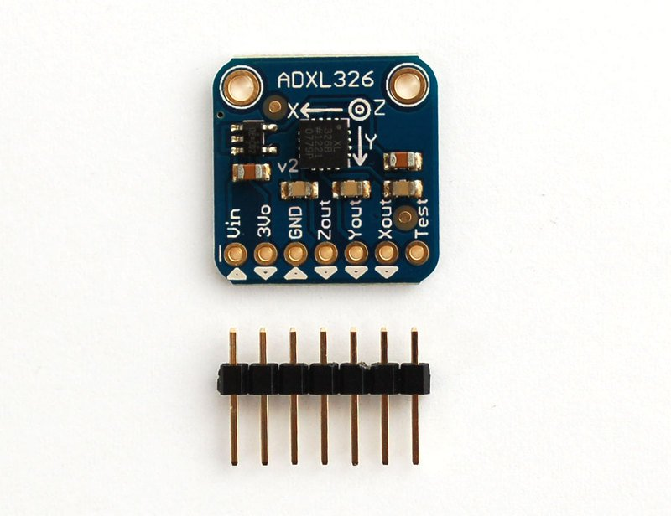

1. **Arm Gripper:**

One of the most important areas in the design of robot systems is the design of end effectors. Most of the problems that occur in production are caused by badly designed tooling and not by faults in the robots.

There are many different types of gripper available along with the vast number of specialist tools for nut running, arc welding, paint spraying etc. These grippers are not used solely with robots however. They can be used for featuring components anywhere in an automated or semi-automated line.

**Sensor capabilities**

For certain applications some degree of sensory feedback from the gripper is necessary. This may be measurement of insertion or gripping forces or may simply be a proximity sensor to say if anything is between the jaws of the gripper.

Some standard grippers are provided with feedback to show the separation of the jaws but most grippers have no feedback.

**Gripper Types**

The most commonly used grippers are finger grippers. These will generally have two opposing fingers or three fingers like a lathe chuck. The fingers are driven together such that once gripped any part is centred in the gripper. This gives some flexibility to the location of components at the pick-up point. Two finger grippers can be further split into parallel motion or angular motion fingers.

For some tasks however where flexible or fragile objects are being handled the use of either vacuum or magnetic grippers is preferable. With these the surface of the gripper is placed in contact with the object and either a magnetic field or a vacuum is applied to hold them in contact. Any errors in placement of the object at the pick-up point will be reflected in a similar error at the destination so these grippers are not usually used for high accuracy applications.

**2.2 Product Description:**

A **gesture controlled robot** is controlled by using hand in place of any other method like buttons or joystick. Here one only needs to move hand to control the robot. A transmitting device is used in your hand which contains RF Transmitter and accelero-meter. This will transmit command to robot so that it can do the required task like moving forward, reverse, turning left, turning right and stop. All these tasks will be performed by using hand gesture.

Here the most important component is accelerometer. Accelerometer is a 3 axis acceleration measurement device with +-3g range. This device is made by using polysilicon surface sensor and signal conditioning circuit to measure acceleration. The output of this device is Analog in nature and proportional to the acceleration. This device measures the static acceleration of gravity when we tilt it. And gives an result in form of motion or vibration.

## 2.3 Preparation of Canvases:

We have included the environment, objects, users, interaction in this canvas.

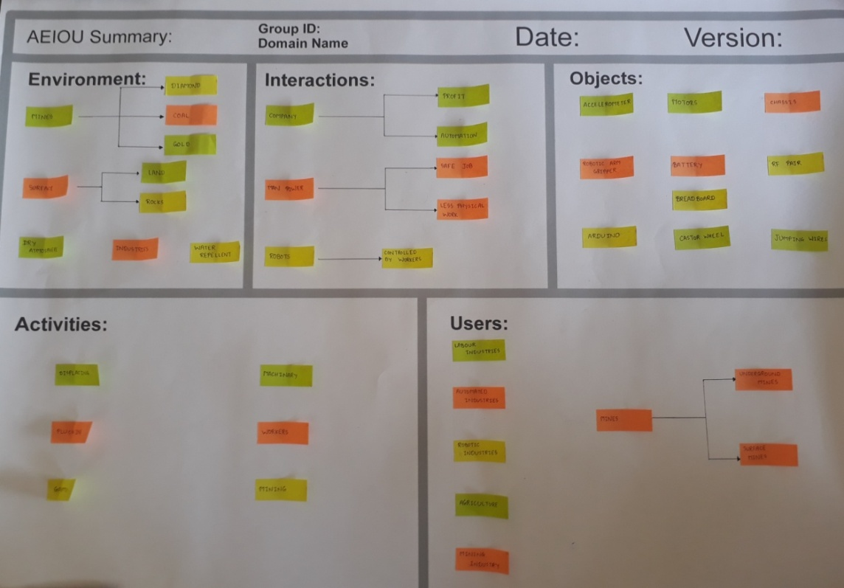

***AEIOU CANVAS***

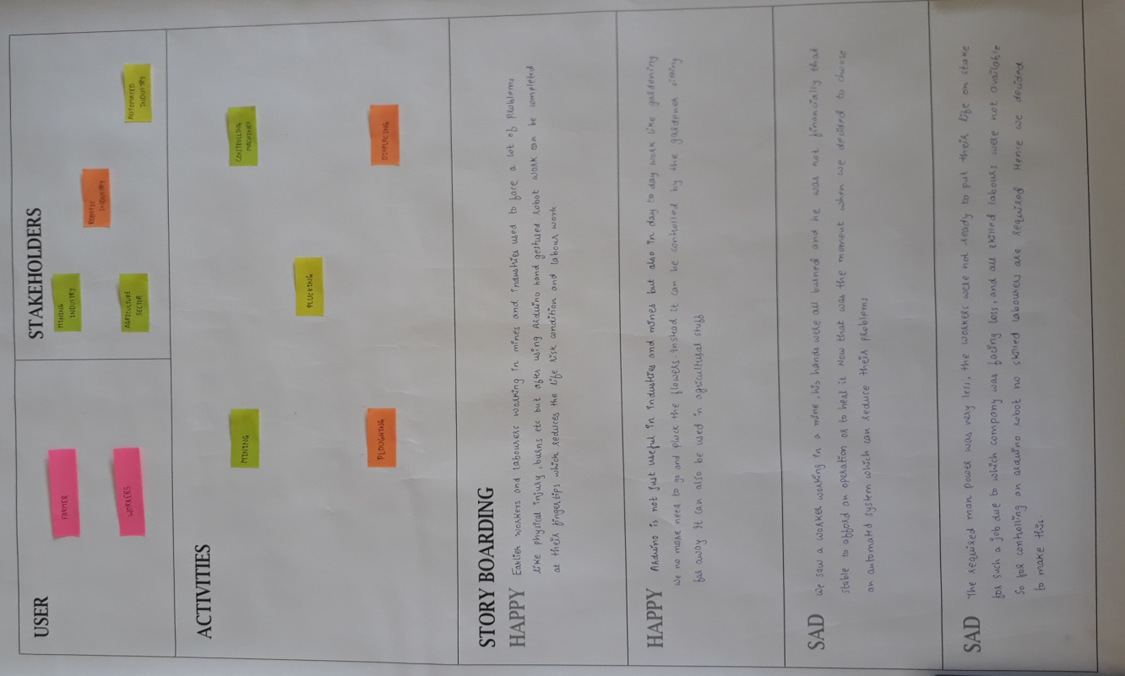

***EMPATHY MAPPING***

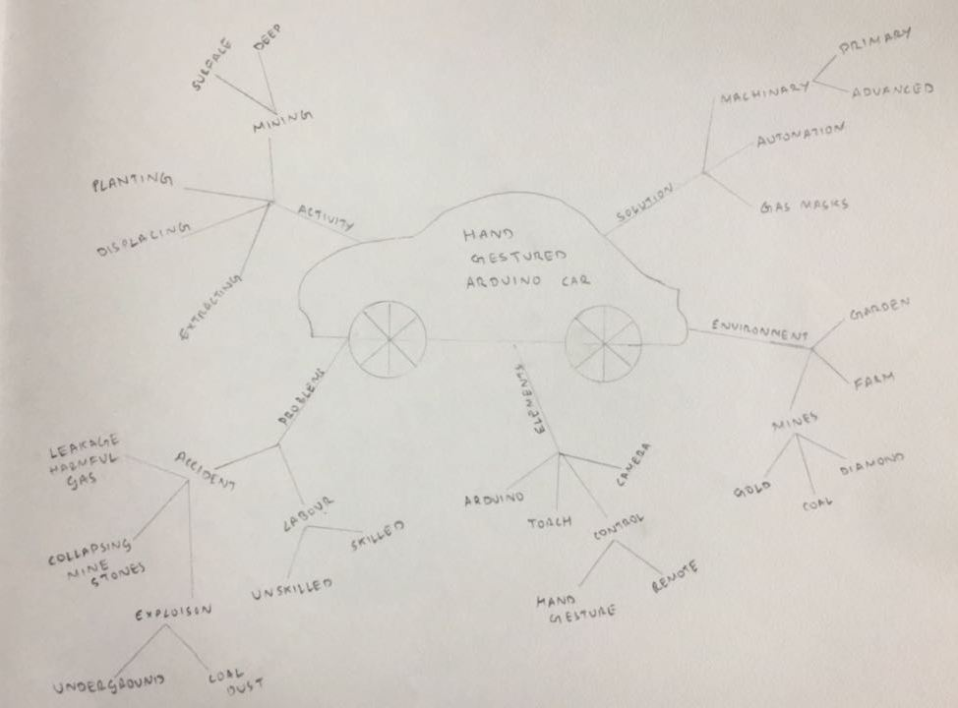

***Mind mapping***

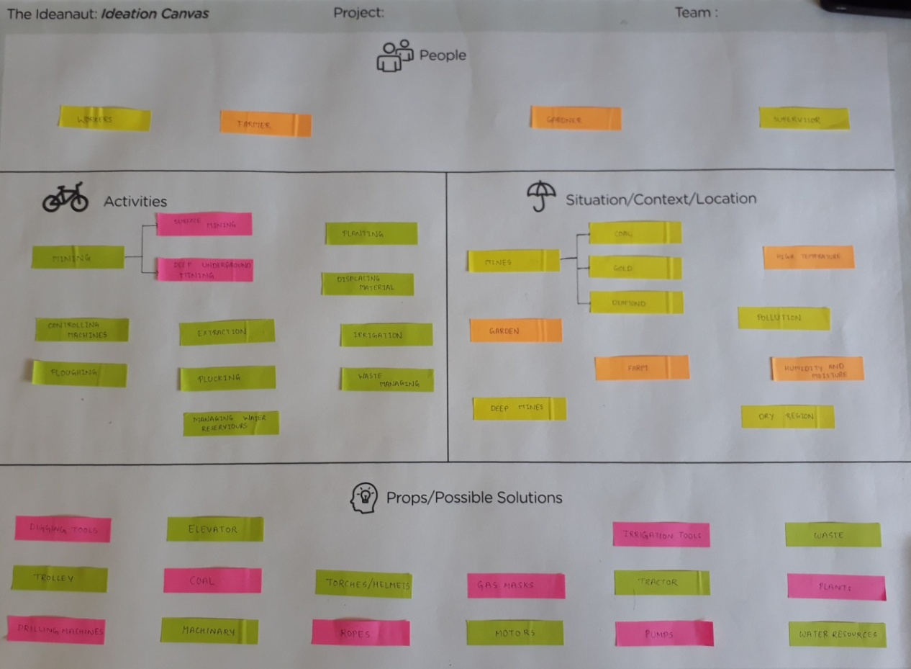

***IDEATION***

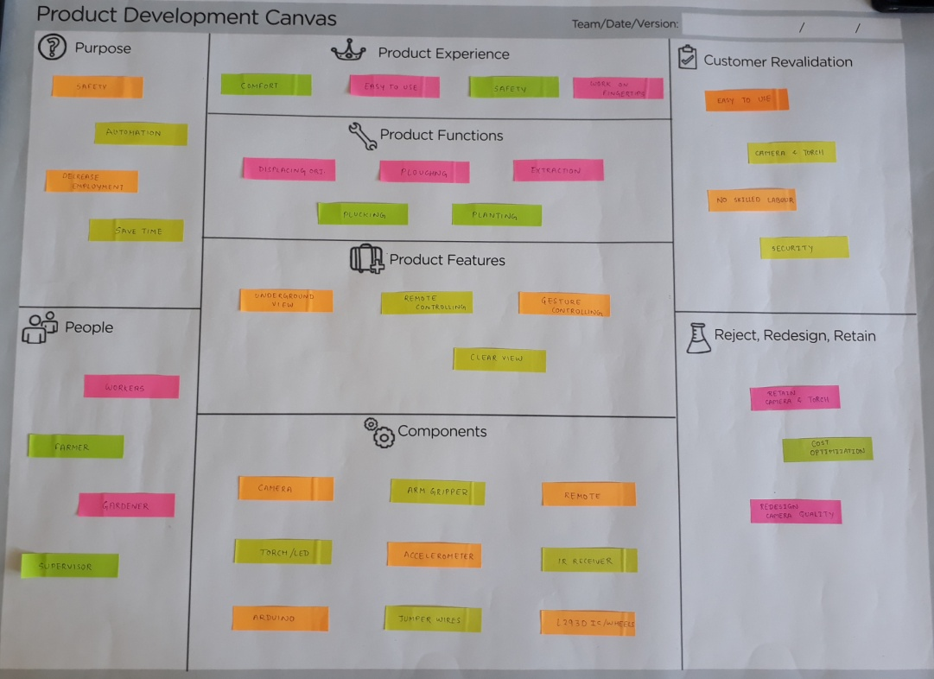

***PRODUCT DEVELOPMENT CANVAS***

## 2.4 FEEDBACK ANALYSIS

The product work with hand gestured is easy to operate. In mines, practically we have to work on large scale but this prototype is helpful. Also to train the workers for using this will not be a very big issue.

LED is useful but it should be powerful nevertheless you can add more than one LED to increase the intensity of light.

The camera is very useful feature and essential too, so therefore its quality should be good enough for clear vision under various circumstances.

## 2.5 SUMMARY OF FINDINGS

1) In conclusion after realizing the under developed areas like mines which inhibits the danger to the human lives we started our project with the notion to automate the regions which needs to be automated.

2) So we have implemented our project on a small scale by using a microcontroller arduino and using various components.

3) We have used camera and LED to get a clear view of the scene. LEDs with more intensity would be used for more reliability over the view.

4) We have also studied some of the research papers on the project related topics and technologies.

## 2.6 SUMMARY OF LEARNING FROM REVERSE ENGINEERING

The benefits of choosing reverse engineering are many:

* Improve efficiency
* Improve performance
* Cost efficiency
* Improve precision
* Upgraded application of technologies

Reverse engineering provides you with a viable alternative for sourcing equipment parts. Reverse engineering gives you the possibility of creating new pieces based on the model you currently use. It also gives you the ability to improve and adapt your parts to better serve your needs. It also allows you to upgrade your systems and parts with new technologies and materials, thus increasing your efficiency and performance capacity. Many times, a reverse engineered piece will outperform its predecessor because of the new materials.

**3. PRE-DESIGN ( LEARNING NEED MATRIX (LNM))**

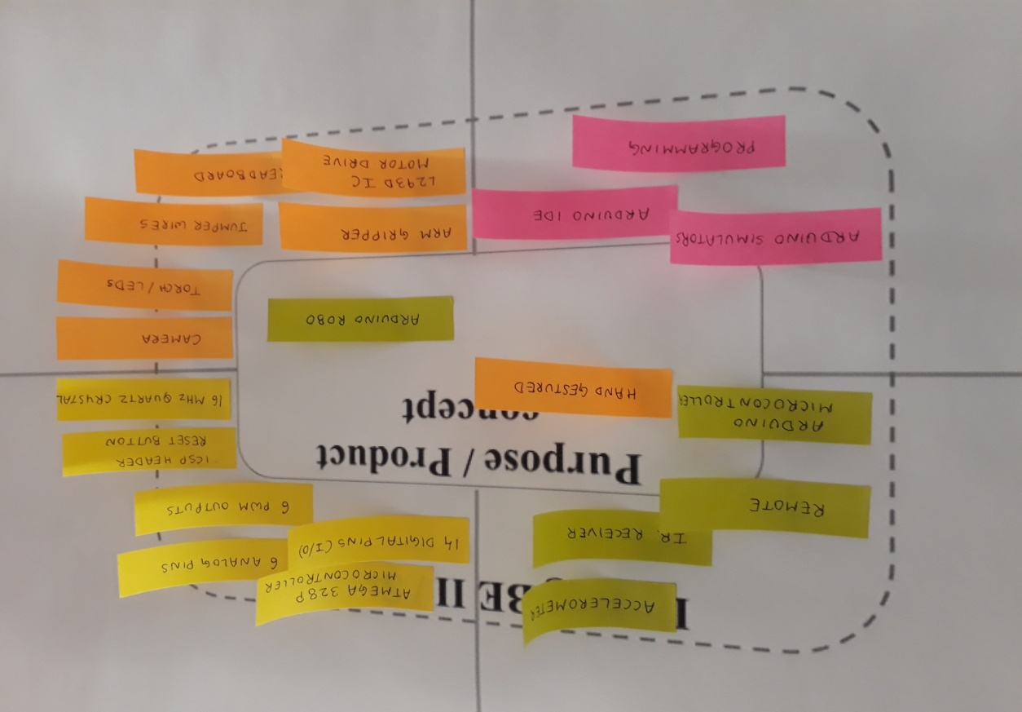

***LNM CANVAS***